Exporting iOS App to device for testing

There is problem with testing app on a device with the latest iOS update. Xcode gives out a bunch of errors. The workaround is to export ipa to devices

**Change Scheme:**

1. 
2. Click on “PocketID_BuildAll” to get you a dropdown. Scroll all the way to bottom.
3. Edit Scheme
4. Archive
5. Build Configuration
6. Change Release to Debug

**Build Archive:**

1. Project
2. Archive

**Export app to file:**

1. Windows > Archives
2. In Archives Screen, click on latest build
3. Click “Export”
4. Save for Dev. Deploy.
5. Pick a Dev. Team
6. There are two “MorphoTrust USA, Inc.” Pick one that doesn’t give you error.
7. Select “Export one app for all compatible devices”
8. Click “Next” in Summary screen
9. Save file (remember where it is saved)

**Load IPA to device:**

1. Window > Devices
2. Click on your device
3. 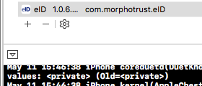
4. Click on + and load IPA file
5. click on to see console screen below

**View Log:**

* Navigate to Download > Eid….xcappdata > AppData > Library > Caches > Logs
* Open log file